Sepsis Final Story Board
https://public.tableau.com/views/SepsisStoryboardFinalVersion_17806720335980/Story1?:language=en-GB&:sid=&:redirect=auth&:display_count=n&:origin=viz_share_link
Lung Analysis
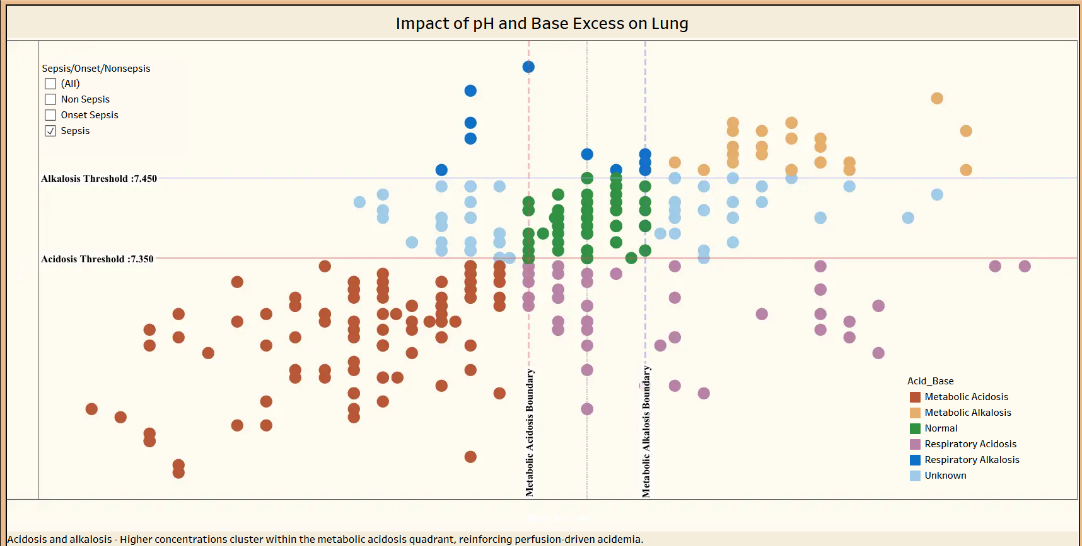
SOFA Analysis
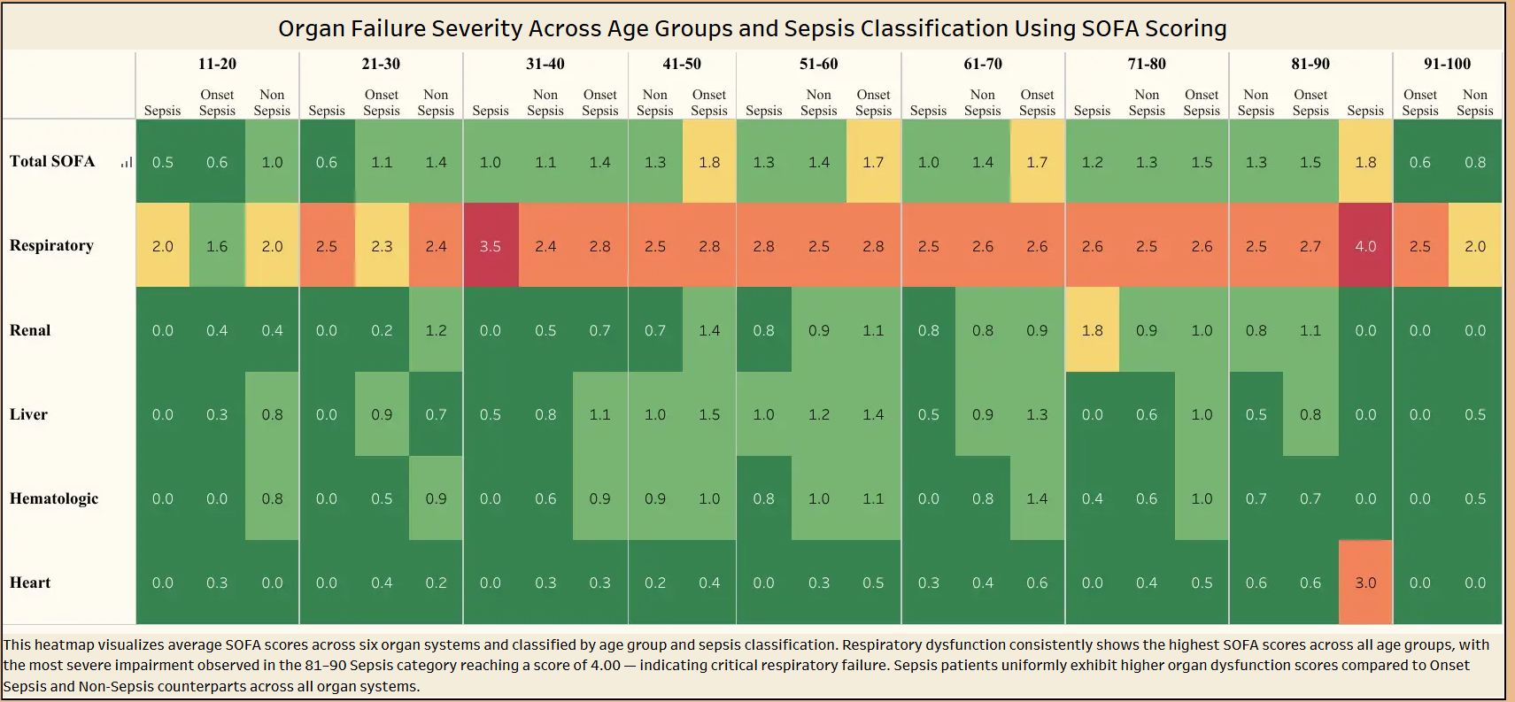
Sepsis MOD Analysis
https://public.tableau.com/views/MODS_Team_1-8_Dashboard_17749842111670/MODS_Analysis?:language=en-GB&:sid=&:redirect=auth&:display_count=n&:origin=viz_share_link

